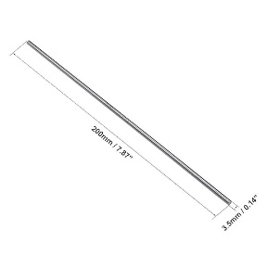**Axle Batteries**

**Battery Adapter Cable Chassis Kit**

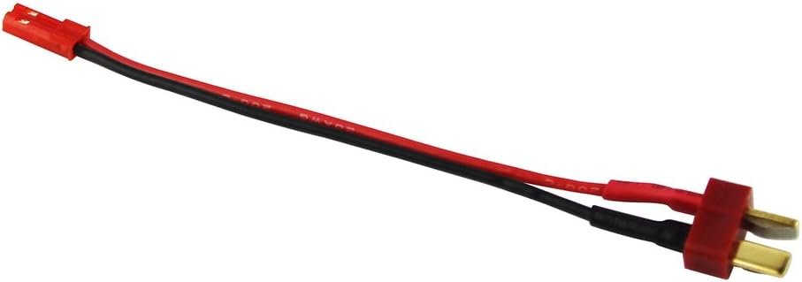

**Spare Wheels ESP32**

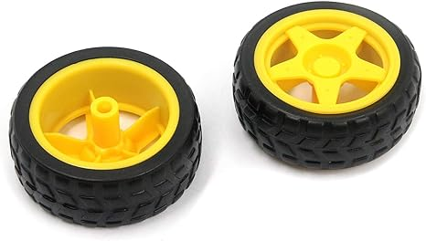

**Voltage Regulators L298N Motor Driver**

**PS3 Controller and Micro USB DC Motor**

**

**DC Motor Mount DC Motor Driver**

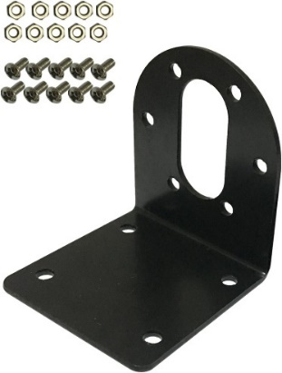 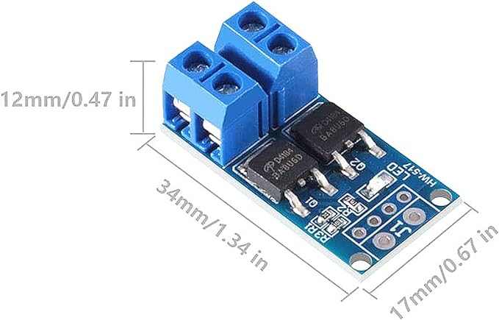

**Servo Motor Driver Servo Motors**

